**Project Design Phase-II**

**Technology Stack (Architecture & Stack)**

|  |  |
| --- | --- |
| **Date** | **15 October 2022** |
| **Team ID** | **PNT2022TMID13481** |
| **Project Name** | **IoT based smart crop protection system for agriculture** |
| **Maximum Name** | **4 Marks** |

**Technical Architecture:**

|  |  |  |  |
| --- | --- | --- | --- |
| **S.No** | Component | Description | Technology |
| **1.** | User Interface | How user interacts with the  Web UI | App development |
| **2.** | Application Logic-1 | Logic for a process in the application | Python Objectives |
| **3.** | Application Logic-2 | Logic for a process in the application | IBM Watson STT  service |
| **4.** | Application Logic-3 | Logic for a process in the application | Node-RED service |
| **5.** | Database | Data Type | Database  Cloudant DB |
| **6.** | Cloud Database | Database Service on Cloud | Cloud Object |

**The Deliverable shall include the architectural diagram as below and the information as per the table1 & table2.**

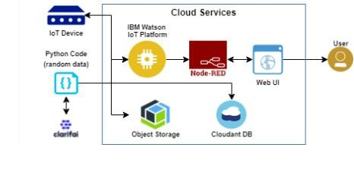

**Table-1: Components & Technologies:**

|  |  |  |  |  |  |  |
| --- | --- | --- | --- | --- | --- | --- |
|  |  | |  | | | store service |
| **7.** | File Storage | | File storage requirements | | | IBM Block Storage |
| **.** | Infrastructure (Server / Cloud) | | Application Deployment on Local System / Cloud Local Server Configuration:  Cloud Server Configuration: | | | Cloud Foundry |
| **S.No** | | **Characteristics** | | **Description** | **Technology** | |
| **1.** | | **Open-source Frameworks** | | **The open-source frameworks used** | **SAN-SAF** | |
| **2.** | | **Security**  **Implementations** | | **List all the security / access controls implemented** | **IBM cloud encryptions** | |
| **3.** | | **Scalable Architecture** | | **Justify the scalability of architecture (3 – tier, Micro-services)** | **IBM cloud Architecture** | |
| **4.** | | **Availability** | | **Justify the availability of applications (e.g. use of load balancers, distributed servers**  **etc.)** | **Web Application can even be used by the framers in the horticulture** | |
| **5.** | | **Performance** | | **Design consideration for the performance of the application** | **Since the web application is high efficient, it can be used by the farmers irrespective of time.** | |